Moksha Patamu

Contents

Game 1

Motivation 1

Game details 1

Game Instructions 1

MVP 2

Wireframe 2

Tech Stack 2

# Game

Snake and Ladders, a classic board game, originated in India, where it was known as Moksha Patamu. The original game had more snakes than ladders, and I will be using this version, thus the name of my game shall follow “Moksha Patamu”.

# Motivation

I chose Snake and Ladders because I really liked playing this game when I was younger, and I thought it was a good game to challenge my coding skills. It would allow me to test my HTML, CSS and JavaScript knowledge.

I think it would be interesting and challenging having to consider the different conditions of snakes and ladders – and for each condition, I would have to code for the piece to move up or down depending on where it landed.

# Game details

1. At least 2 players are required for the game.

2. The player has to roll a 6 sided dice and move their piece accordingly to the game rules.

3. First player to reach the 100th tile wins.

# Game Instructions

The first player that reaches the highest tile on the board, 100, wins the game. When you land at the bottom of a ladder, your piece would move up. Landing at the top of a ladder does nothing. When you land at the top of a snake, your piece would move down. Landing at the base of a snake does nothing.

Note that a player will have to roll the exact number required to land their piece on the 100th tile. So if the player rolls a higher number than needed to land exactly on 100, their piece does not move and remains there until their next turn.

For example: Player piece is on tile 97, and rolls a 4. Since 97 + 4 = 101, player remains on 97.

Player piece is on tile 97, and rolls a 1. Since 97 + 1 = 98, player moves to 98.

# MVP

The game will need to have the following features at minimum:

* A title at the top stating the name of the game
* A 10x10 board with tiles 1 to 100, with snakes and ladders on the board
* 2 pieces representing the players, to be placed on the tiles
* A button for player to click for the dice roll
* Popup that declares a player has reached 100

# Extra features

The game should ideally also include:

* A screen displaying the value of the dice roll
* Player 1’s tile number
* Player 2’s tile number
* Buttons for dark mode and light mode
* Button to start another game / restart game
* Rules of the game
* Autoplay feature so users don’t have to keep clicking the button for dice roll
* Music
* More players
* Prompt for users to add items, once game ends, popup will randomly pick an item from the items array saying that the loser must treat the winner item X

# Wireframe

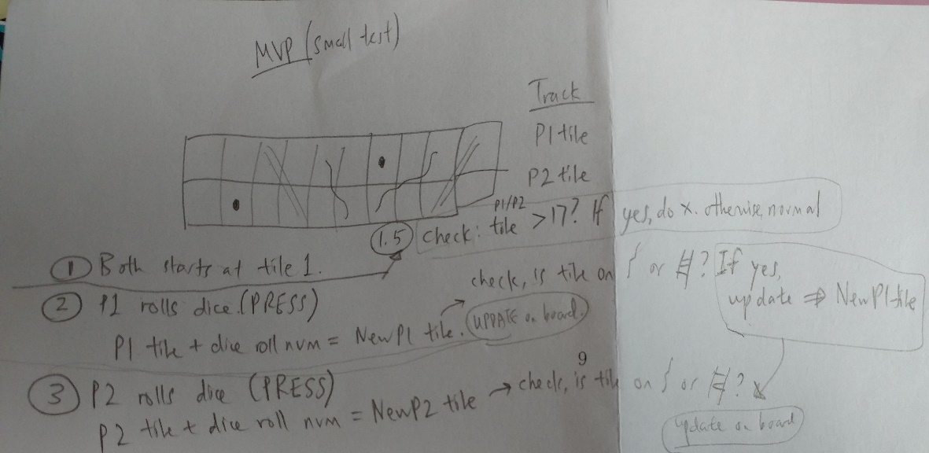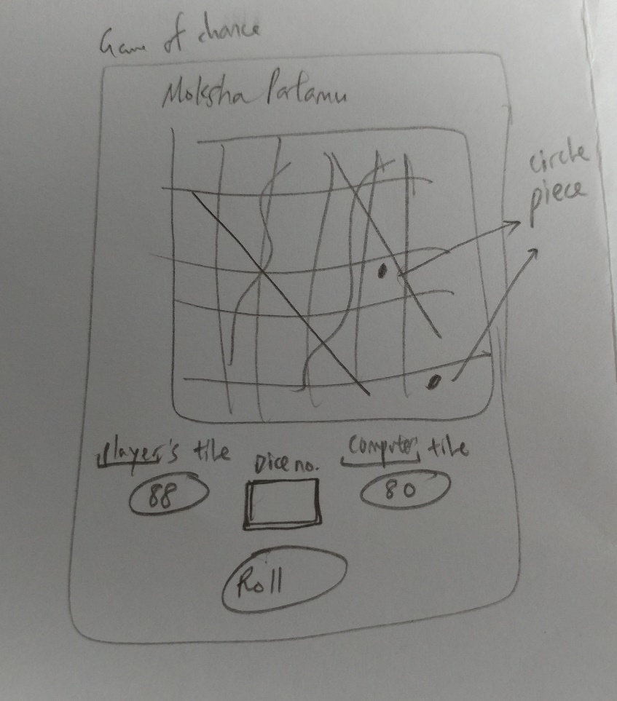

# Tech Stack

* HTML
* CSS (+bootstrap)
* Javascript (+jQuery)
* Photoshop